Phase 2: Submission

Tittle: Smart Public Restroom

Name: Johncy mery A

Naan Mudhalvan id: au953021106026

College code: 9530

Problem Statement:

* Many smart toilets have automatic flushing and hands-free operation (especially after COVID) to help keep surfaces and floors clean.
* Most of the public toilets are not clean due to the irresponsible peoples who often forget to flush the toilet after using it.
* There were also worries about the risk of losing sensitive data to hackers, as well as the possibility of companies selling the data on deliberately.
* And if smart toilets were installed in public areas or workplaces, there would be questions about who has access to that data, it was argued.

List of Compounents:

* Aurdino
* Aurdino IDE Software
* Ultrasonic sensor
* DC Motor
* LCD
* Potentiometer
* Breadboard
* Led
* Resistor

Flow Chart

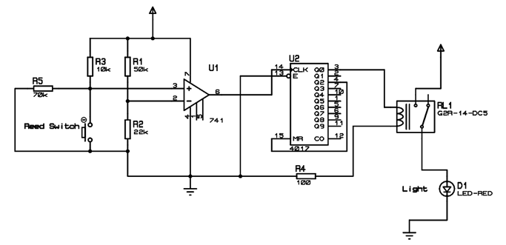

Software used:

* Aurdino IDE
* Arduino Integrated Development Environment (IDE) is an open source IDE that allows users to write code and upload it to any Arduino board.
* Arduino IDE is written in Java and is compatible with Windows, macOS and Linux operating systems.
* Arduino is important part in robotics because it provide creativity and problem-solving.
* It is plugged in the computer and programmed with easy commands i.e. when Arduino is placed in a circuit, and it will manipulate the functioning of the device.
* It emphasizes the involvement of Arduino in many things around.

Hardware used:

Aurdino:

* Arduino is an open hardware development board that can be used by tinkerers, hobbyists, and makers to design and build devices that interact with the real world.

Ultrasonic sensor

* An ultrasonic sensor is an instrument that measures the distance to an object using ultrasonic sound waves.
* An ultrasonic sensor uses a transducer to send and receive ultrasonic pulses that relay back information about an object's proximity.

Jumper Wires:

* It is used to connect the components to each other.

DC Motor:

* DC motors, or direct current motors, are electrical devices that convert electrical energy into mechanical energy.

LCD:

* LCD, or Liquid Crystal Display, technology is widely used in various applications due to its compactness, energy efficiency, and ability to produce high-quality visuals.

Led:

* + Light Emitting Diodes (LEDs) have become increasingly popular due to their energy efficiency, longevity, and versatility in various applications.

Potentiometer:

* Potentiometers are frequently used in audio equipment like amplifiers, radios, and home stereo systems to adjust and control the volume of sound output.

Breadboard:

* Breadboards are essential tools in electronics prototyping and experimentation. They are versatile, reusable, and allow you to quickly and easily create and test electronic circuits without soldering.

Resistor:

* Resistors are passive electronic components that are widely used in various electrical and electronic circuits to control the flow of electric current.

Circuit Diagram:

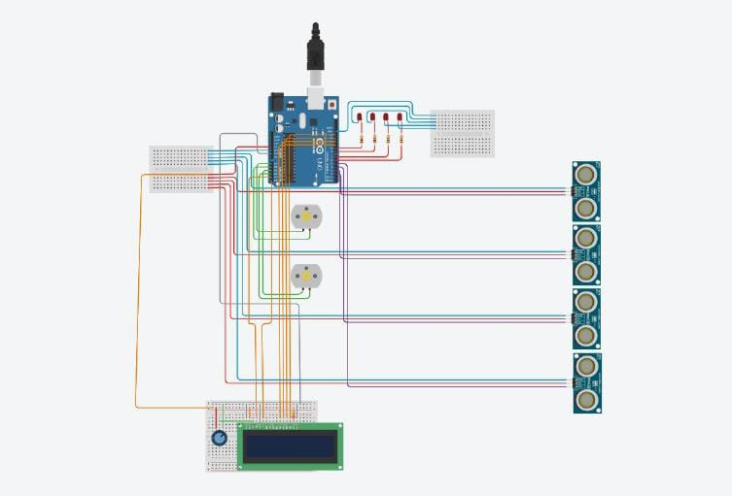

Description:

* smart toilet is a plumbing fixture that incorporates technology to add additional functionality such as self-cleaning, lighting, warming and massaging features to a toilet. Smart toilets can be controlled with voice command, remote control or mobile apps.
* Toilet technology has evolved significantly, with smart toilets offering features like self-cleaning, hands-free sensors, and water-saving technologies.
* Traditional or attachable, bidets can improve hygiene and reduce toilet paper consumption, making them environmentally friendly